**IDEATION PHASE**

**BRAINSTORM & IDEA PRIORITIZATION**

| Team ID | PNT2022TMID20252 |
| --- | --- |
| Project Name | IoT based smart crop protection system for agriculture |

| **S.No** | **ID NUMBER** | **POSITION** | **NAME** |
| --- | --- | --- | --- |
| 1. | 727819TUEC230 | Team Leader | Sneha P |
| 2. | 727819TUEC231 | Team Member | Sobiha Devi U |
| 3. | 727819TUEC253 | Team Member | Vishnu Ram M |
| 4. | 727819TUEC803 | Team Member | Vinesh Kumar K |

**STEP 1:PROBLEM STATEMENT:**

* How might we protect the crops from heavy rainfall and increase the yield?
* How to monitor the soil moisture levels in the field and also the temperature and humidity values near the field?

**STEP 2: BRAINSTORMING & IDEA GROUPING**

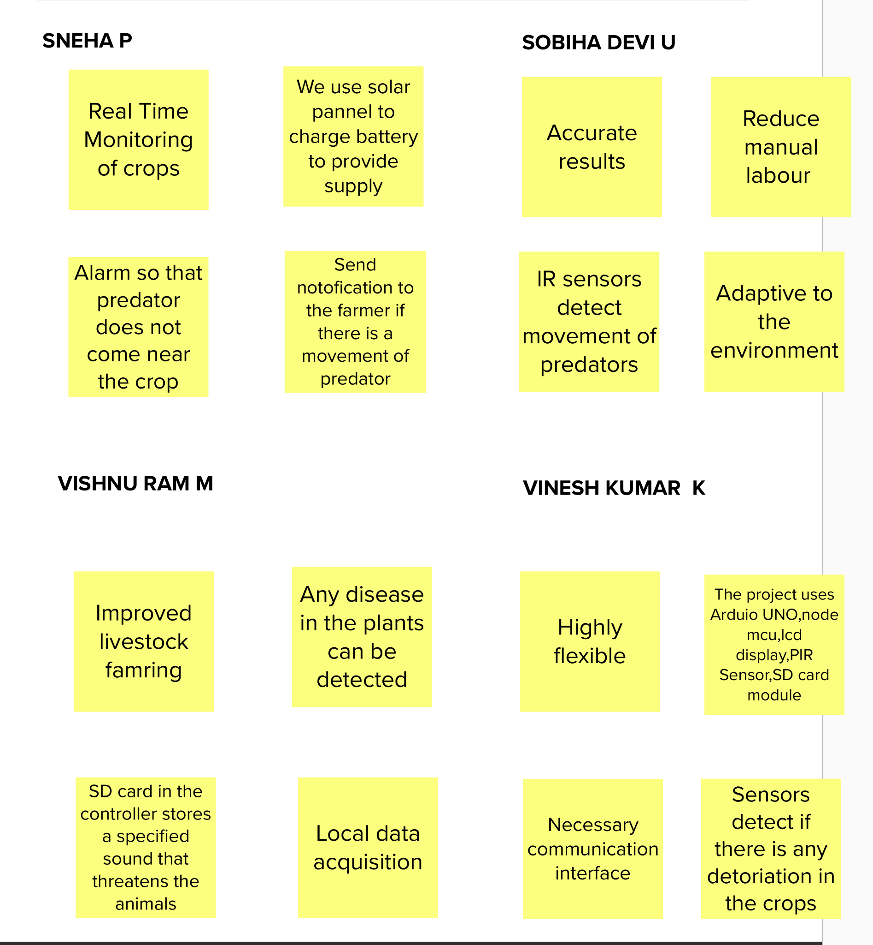

**GROUP IDEAS**

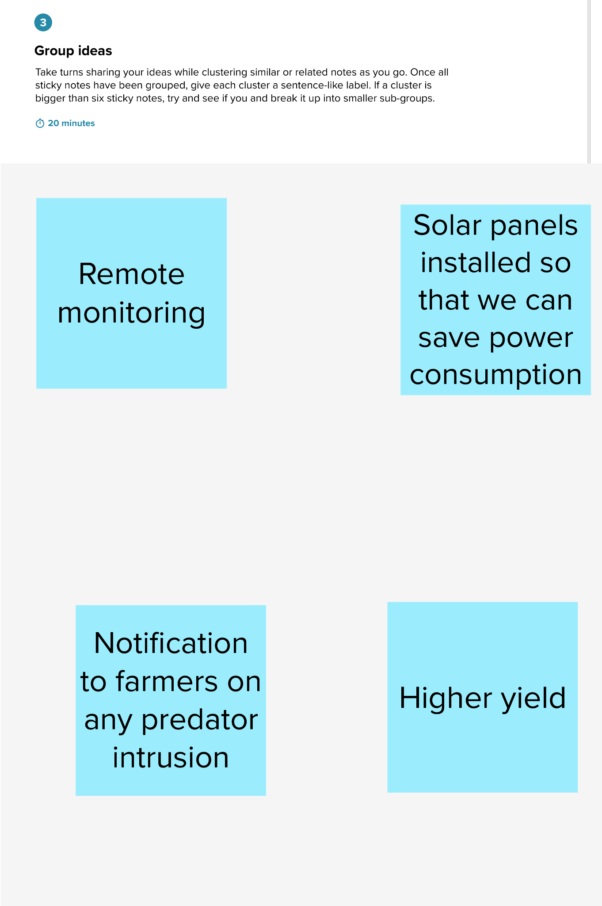

**STEP 3:IDEA PRIORITIZATION**

